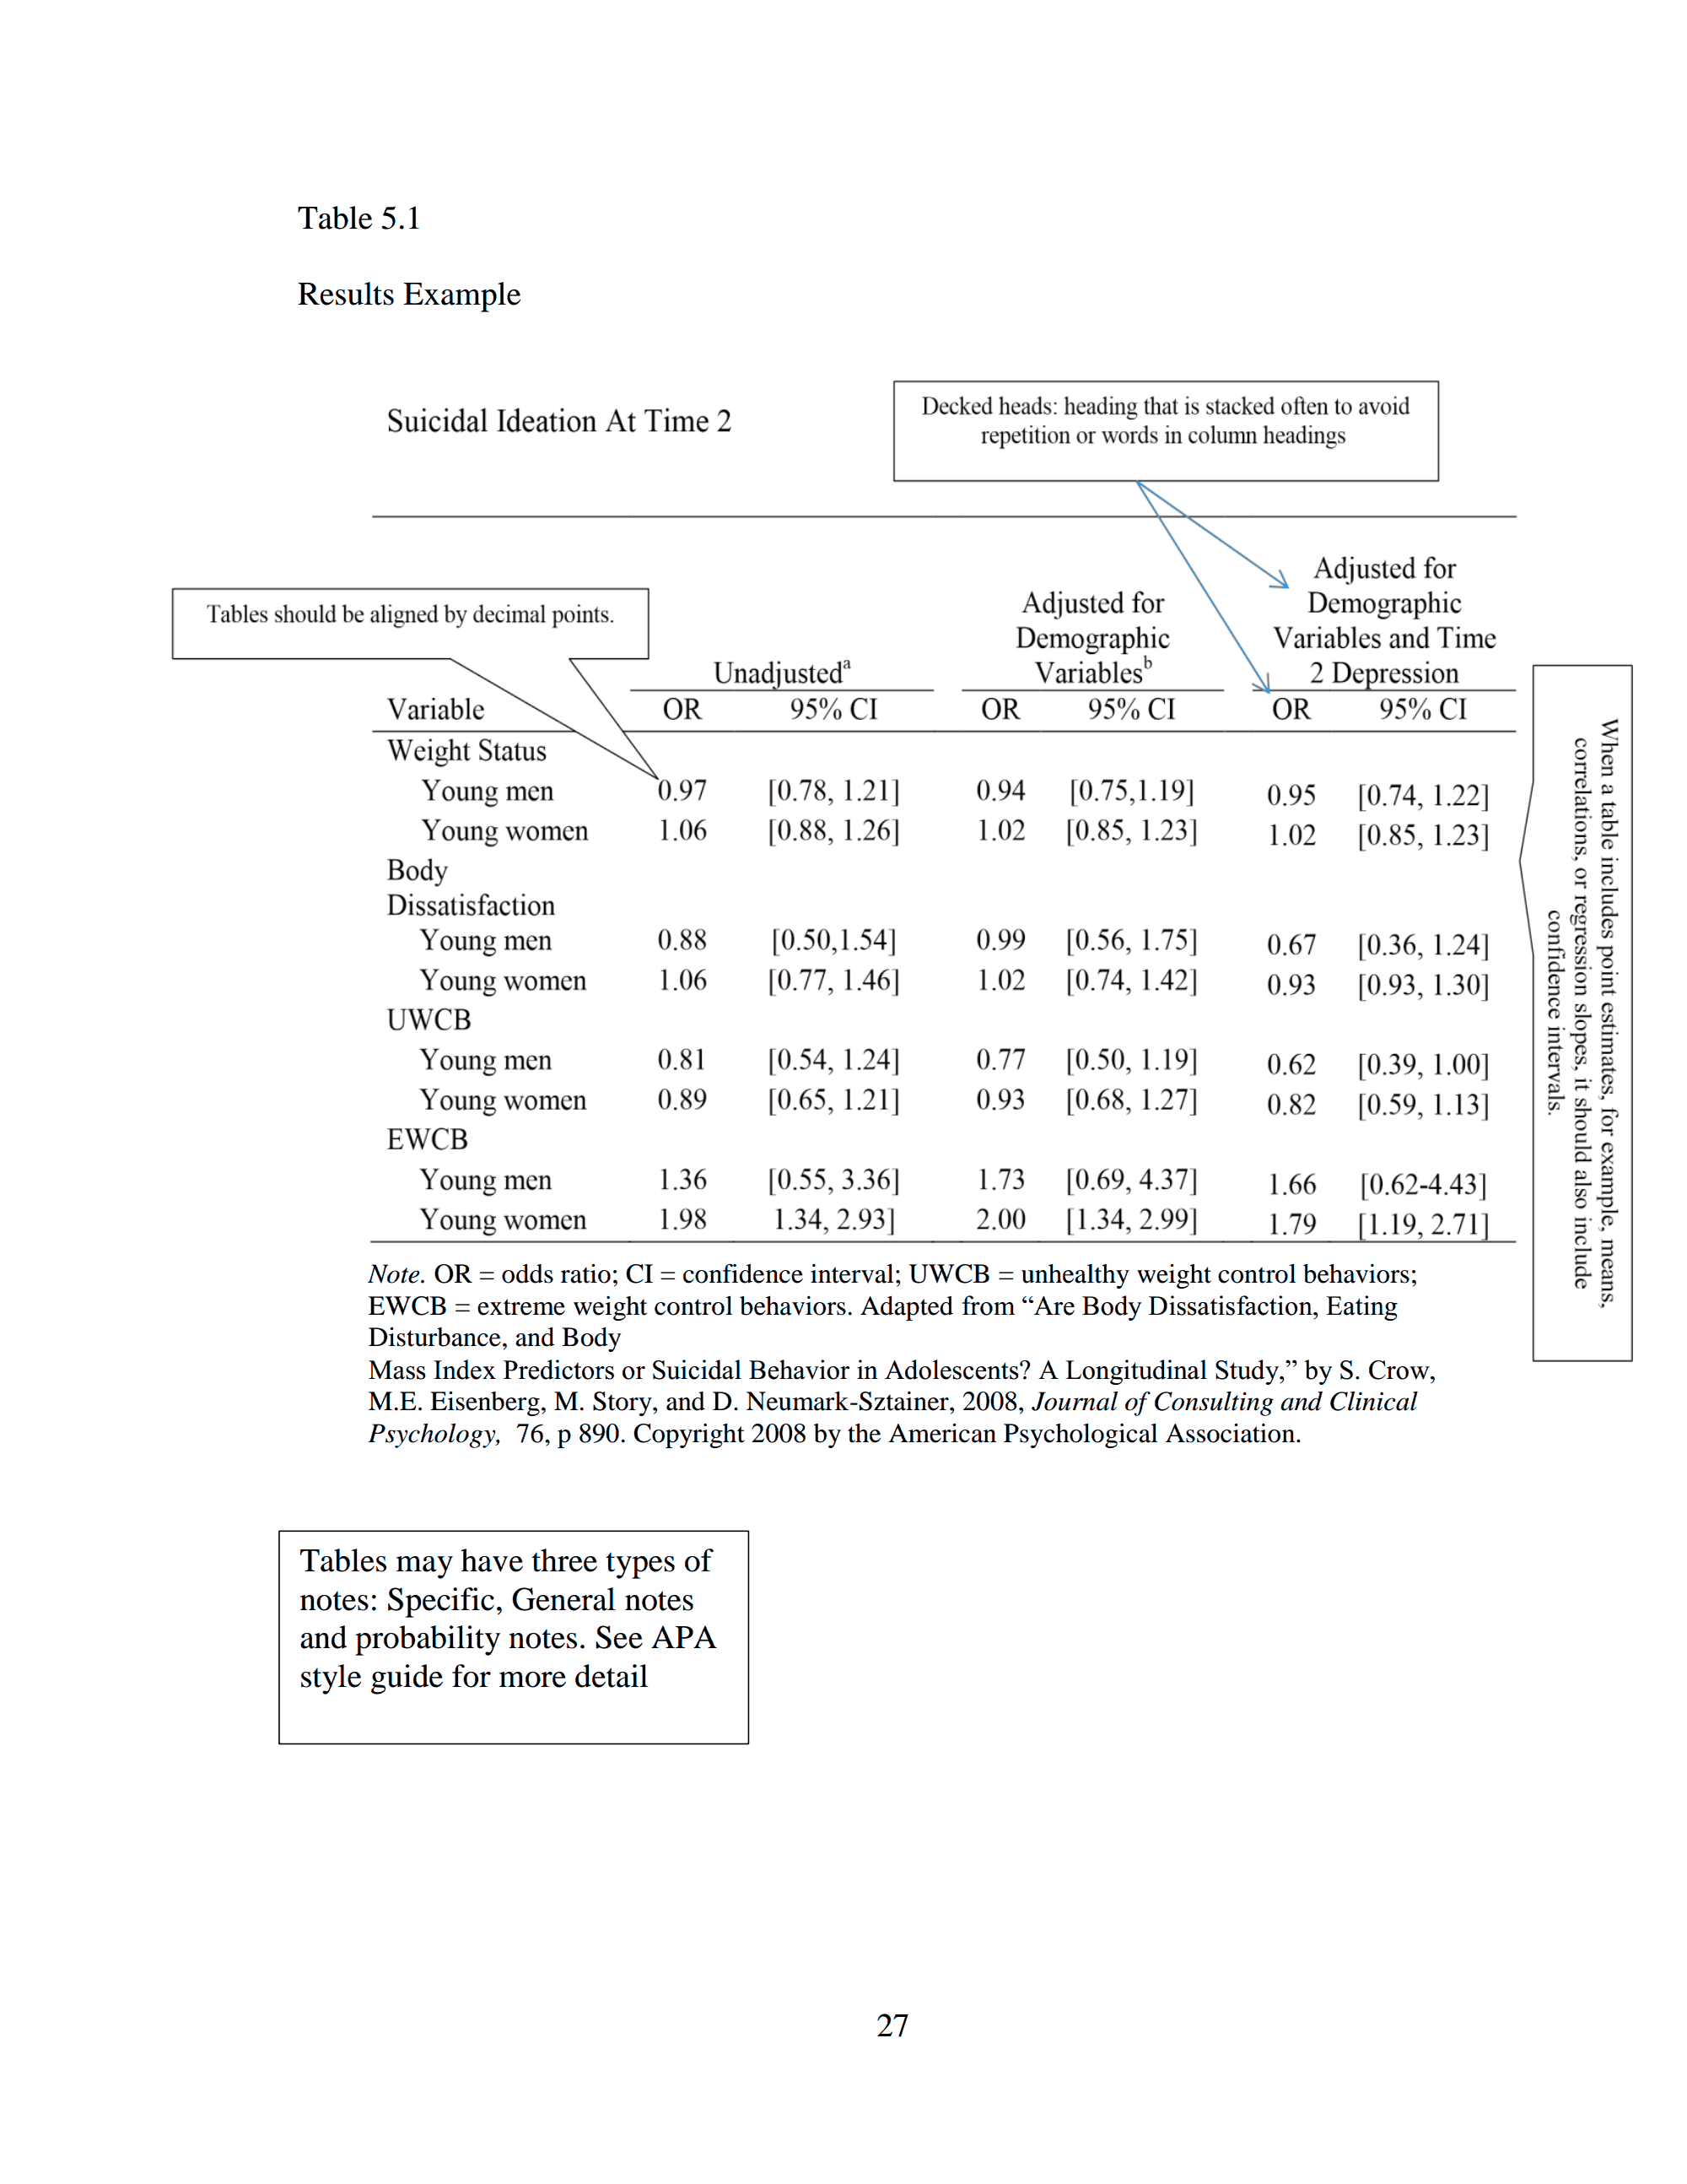
:
Click here for information on how to align tables by decimal points

Also note that numbers in tables should extend 2 decimal places.
Table 6:
Weight Status, Body Dissatisfaction, and Weight Control Behaviors At Time 1 And Suicidal Ideation At Time 2
 | Unadjustedª |  |  | Adjusted for Demographic Variables^{b} |  |  | Adjusted for Demographic Variables and Time 2 Depression
Variable | OR | 95% CI |  | OR | 95% CI |  | OR | 95% CI
Weight Status
Young men | 0.97 | [0.78, 1.21] |  | 0.94 | [0.75,1.19] |  | 0.95 | [0.74, 1.22]
Young women | 1.06 | [0.88, 1.26] |  | 1.02 | [0.85, 1.23] |  | 1.02 | [0.85, 1.23]
Body Dissatisfaction
Young men | 0.88 | [0.50,1.54] |  | 0.99 | [0.56, 1.75] |  | 0.67 | [0.36, 1.24]
Young women | 1.06 | [0.77, 1.46] |  | 1.02 | [0.74, 1.42] |  | 0.93 | [0.93, 1.30]
UWCB
Young men | 0.81 | [0.54, 1.24] |  | 0.77 | [0.50, 1.19] |  | 0.62 | [0.39, 1.00]
Young women | 0.89 | [0.65, 1.21] |  | 0.93 | [0.68, 1.27] |  | 0.82 | [0.59, 1.13]
EWCB
Young men | 1.36 | [0.55, 3.36] |  | 1.73 | [0.69, 4.37] |  | 1.66 | [0.62-4.43]
Young women | 1.98 | 1.34, 2.93] |  | 2.00 | [1.34, 2.99] |  | 1.79 | [1.19, 2.71]

Table 7:
Fixed Effects Estimates Of The Predictors Of Positive Parenting
Parameter | Model 1 | Model 2 | Model 3 | Model 4 | Model 5
Intercept | 12.51 (0.04) | 12.23 (0.07) | 12.23 (0.07) | 12.23 (0.07) | 12.64 (0.11)
Level 1 (Child Specific)
Age |  | -0.49* (0.02) | -0.48* (0.02) | -0.48* (0.02) | -0.48*  (0.02)  Standard errors or confidence interval should be displayed in tables with means, correlations, or regression slopes.
Age² |  | 0.06* (0.01) | 0.06* (0.01) | 0.06* (0.01) | 0.06* (0.01)
Negative Affectivity |  | -0.56* (0.08) | -0.53* (0.08) | -0.57* (0.09) | -0.57*  (0.09)
Girl |  | 0.05  (0.05) | 0.05 (0.05) | 0.04 (0.05) | 0.07 (0.05)
Not bio. mother |  | -0.34 (0.26) | -0.28 (0.26) | -0.28 (0.26) | -0.30 (0.28)
Not bio. father |  | -0.34* (0.10) | -0.31* (0.10) | -0.30* (0.10) | -0.29 (0.15)
oldest sibling |  | 0.38* (0.07) | 0.37* (0.07) | 0.37* (0.07) | 0.36* (0.07)
middle sibling |  | -0.36 * (0.06) | -0.34* (0.06) | -0.35* (0.06) | -0.28*  (0.06)
Level 2 (family)
SES |  |  |  |  | 0.18* (0.06)
Marital dissatisfaction |  |  |  |  | -0.43* (0.14)
Family size |  |  |  |  | -0.41* (0.08)
Single Parent |  |  |  |  | 0.09 (0.19)
All-girl sibship |  |  |  |  | -0.20 (0.13)
Mixed gender sibship |  |  |  |  | -0.25* (0.10)
Note: Standard errors are in parentheses. Not bio. mother = not living with biological mother; not bio. father = not living with biological father; SES = socioeconomic status. Adapted from “The Role of the Shared Family Context in Differential Parenting,” by J.M. Jenkins, J. Rasbash, and T.G. O’Connor, 2003, Developmental Psychology, 39, p. 104. Copyright 2003 by the American Psychological Association.
*p<0.05.
Note: When making your regression tables, you can choose whether to include confidence intervals or standard error.

Note should include significance values

